Snímka 1

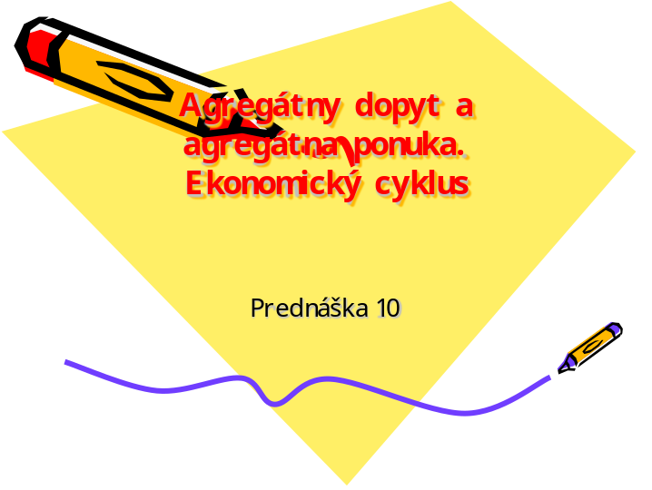

____________________________________________________________________________________________________________________________________________________________________________________________________________________________________________________________________________________________________________________________________________________________________________________________________________________________________________________________________________________________________________________________________________________________________________________________________________________________________________________________________________________________________________________________________________________________________________________________________________________________________________________________________________________________

Snímka 2

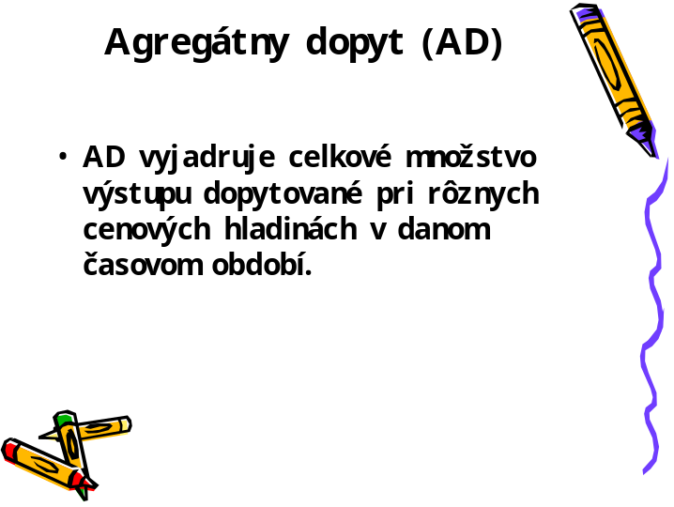

____________________________________________________________________________________________________________________________________________________________________________________________________________________________________________________________________________________________________________________________________________________________________________________________________________________________________________________________________________________________________________________________________________________________________________________________________________________________________________________________________________________________________________________________________________________________________________________________________________________________________________________________________________________________

Snímka 3

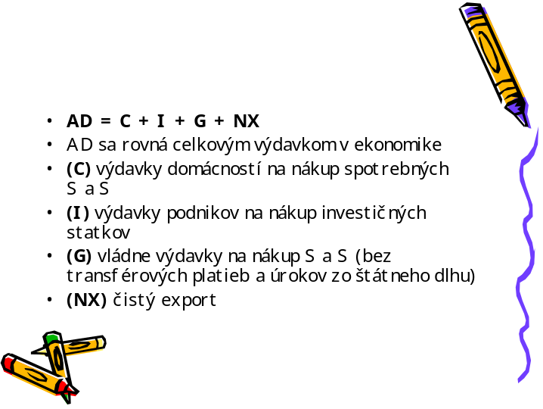

____________________________________________________________________________________________________________________________________________________________________________________________________________________________________________________________________________________________________________________________________________________________________________________________________________________________________________________________________________________________________________________________________________________________________________________________________________________________________________________________________________________________________________________________________________________________________________________________________________________________________________________________________________________________

Snímka 4

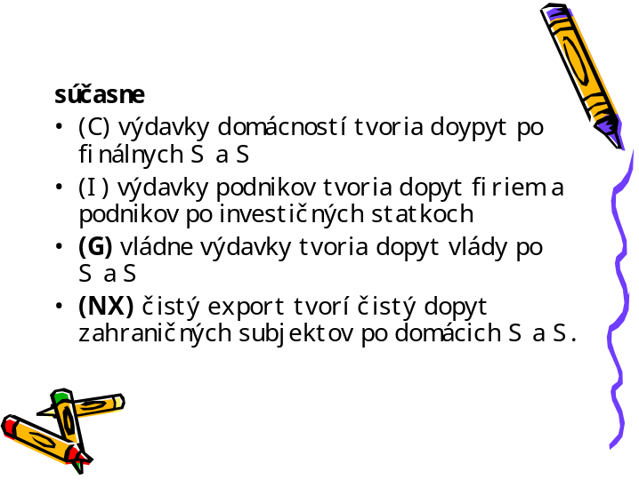

____________________________________________________________________________________________________________________________________________________________________________________________________________________________________________________________________________________________________________________________________________________________________________________________________________________________________________________________________________________________________________________________________________________________________________________________________________________________________________________________________________________________________________________________________________________________________________________________________________________________________________________________________________________________

Snímka 5

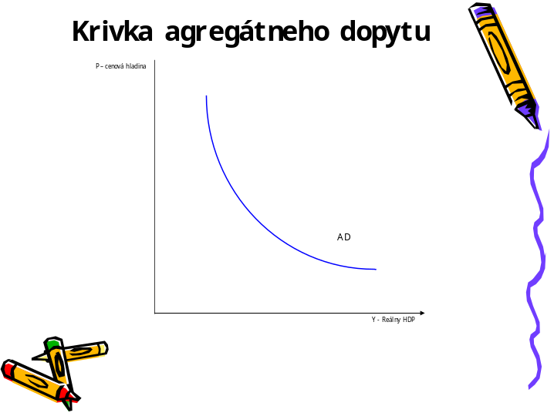

____________________________________________________________________________________________________________________________________________________________________________________________________________________________________________________________________________________________________________________________________________________________________________________________________________________________________________________________________________________________________________________________________________________________________________________________________________________________________________________________________________________________________________________________________________________________________________________________________________________________________________________________________________________________

Snímka 6

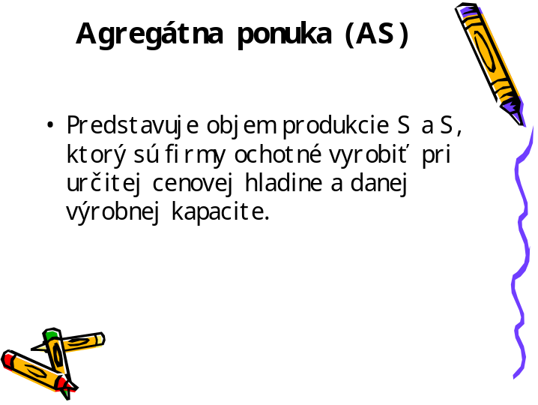

____________________________________________________________________________________________________________________________________________________________________________________________________________________________________________________________________________________________________________________________________________________________________________________________________________________________________________________________________________________________________________________________________________________________________________________________________________________________________________________________________________________________________________________________________________________________________________________________________________________________________________________________________________________________

Snímka 7

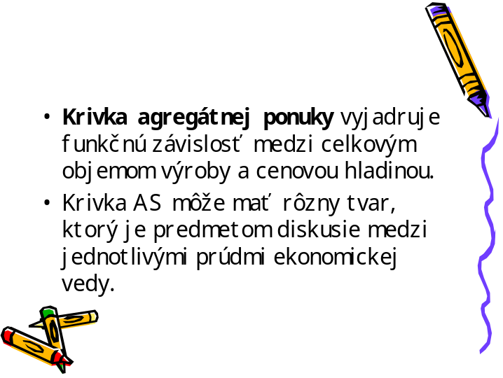

____________________________________________________________________________________________________________________________________________________________________________________________________________________________________________________________________________________________________________________________________________________________________________________________________________________________________________________________________________________________________________________________________________________________________________________________________________________________________________________________________________________________________________________________________________________________________________________________________________________________________________________________________________________________

Snímka 8

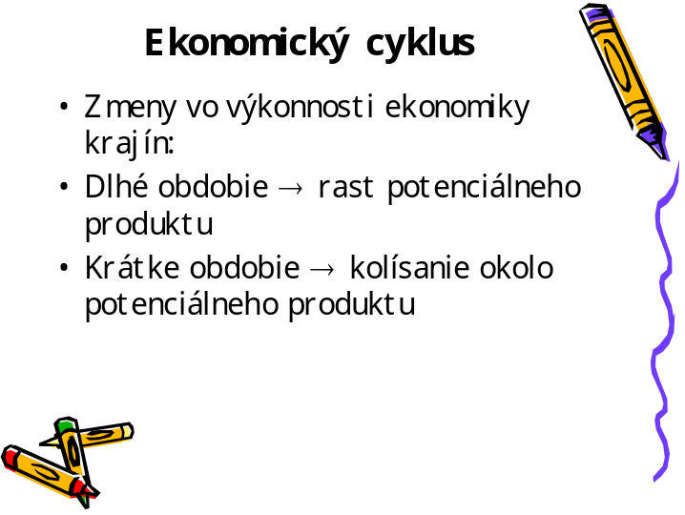

____________________________________________________________________________________________________________________________________________________________________________________________________________________________________________________________________________________________________________________________________________________________________________________________________________________________________________________________________________________________________________________________________________________________________________________________________________________________________________________________________________________________________________________________________________________________________________________________________________________________________________________________________________________________

Snímka 9

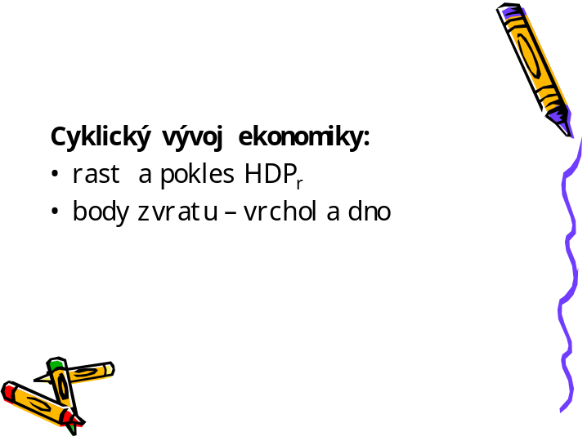

____________________________________________________________________________________________________________________________________________________________________________________________________________________________________________________________________________________________________________________________________________________________________________________________________________________________________________________________________________________________________________________________________________________________________________________________________________________________________________________________________________________________________________________________________________________________________________________________________________________________________________________________________________________________

Snímka 10

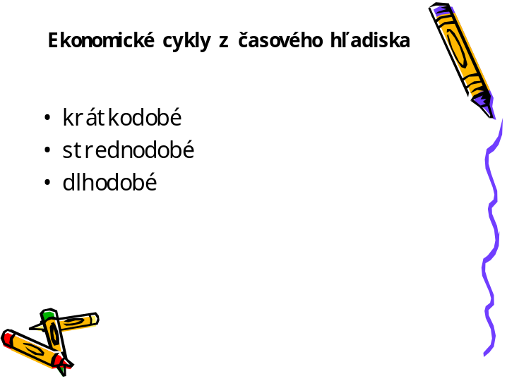

____________________________________________________________________________________________________________________________________________________________________________________________________________________________________________________________________________________________________________________________________________________________________________________________________________________________________________________________________________________________________________________________________________________________________________________________________________________________________________________________________________________________________________________________________________________________________________________________________________________________________________________________________________________________

Snímka 11

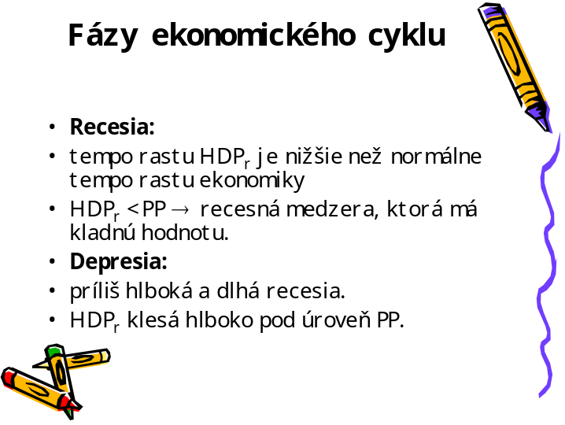

____________________________________________________________________________________________________________________________________________________________________________________________________________________________________________________________________________________________________________________________________________________________________________________________________________________________________________________________________________________________________________________________________________________________________________________________________________________________________________________________________________________________________________________________________________________________________________________________________________________________________________________________________________________________

Snímka 12

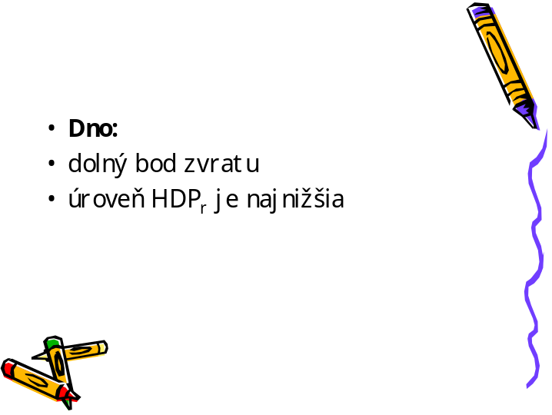

____________________________________________________________________________________________________________________________________________________________________________________________________________________________________________________________________________________________________________________________________________________________________________________________________________________________________________________________________________________________________________________________________________________________________________________________________________________________________________________________________________________________________________________________________________________________________________________________________________________________________________________________________________________________

Snímka 13

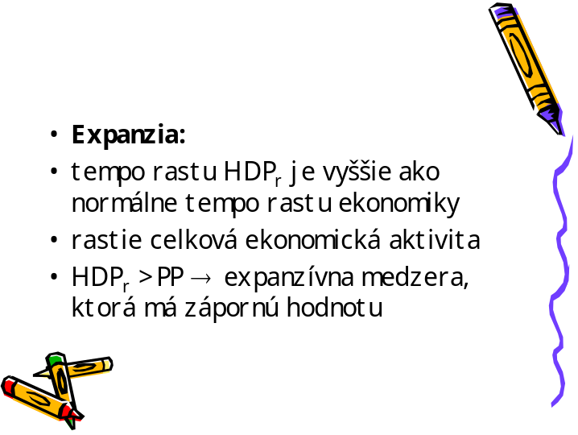

____________________________________________________________________________________________________________________________________________________________________________________________________________________________________________________________________________________________________________________________________________________________________________________________________________________________________________________________________________________________________________________________________________________________________________________________________________________________________________________________________________________________________________________________________________________________________________________________________________________________________________________________________________________________

Snímka 14

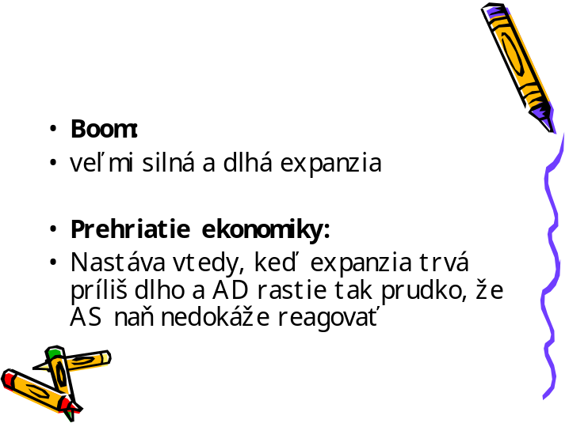

____________________________________________________________________________________________________________________________________________________________________________________________________________________________________________________________________________________________________________________________________________________________________________________________________________________________________________________________________________________________________________________________________________________________________________________________________________________________________________________________________________________________________________________________________________________________________________________________________________________________________________________________________________________________

Snímka 15





