snímek 1

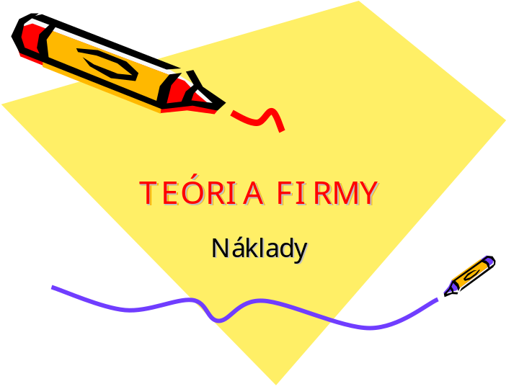

____________________________________________________________________________________________________________________________________________________________________________________________________________________________________________________________________________________________________________________________________________________________________________________________________________________________________________________________________________________________________________________________________________________________________________________________________________________________________________________________________________________________________________________________________________________________________________________________________________________________________________________________________________________________
snímek 2

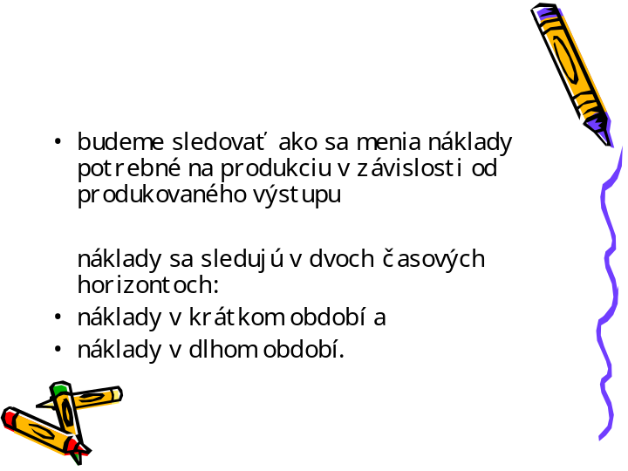

____________________________________________________________________________________________________________________________________________________________________________________________________________________________________________________________________________________________________________________________________________________________________________________________________________________________________________________________________________________________________________________________________________________________________________________________________________________________________________________________________________________________________________________________________________________________________________________________________________________________________________________________________________________________
snímek 3

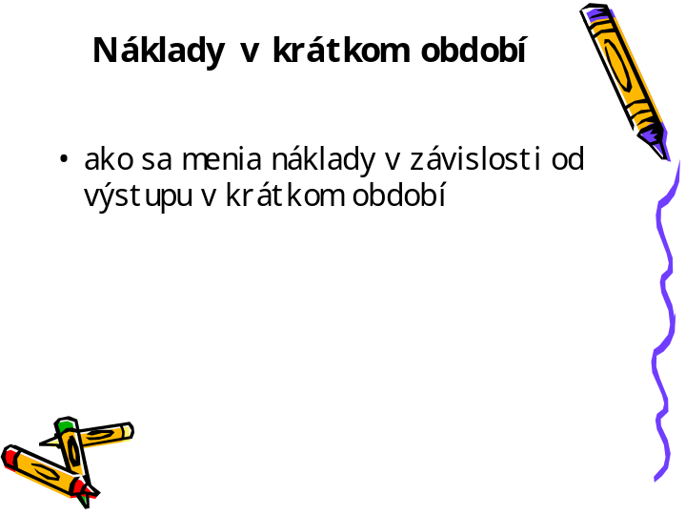

____________________________________________________________________________________________________________________________________________________________________________________________________________________________________________________________________________________________________________________________________________________________________________________________________________________________________________________________________________________________________________________________________________________________________________________________________________________________________________________________________________________________________________________________________________________________________________________________________________________________________________________________________________________________
snímek 4

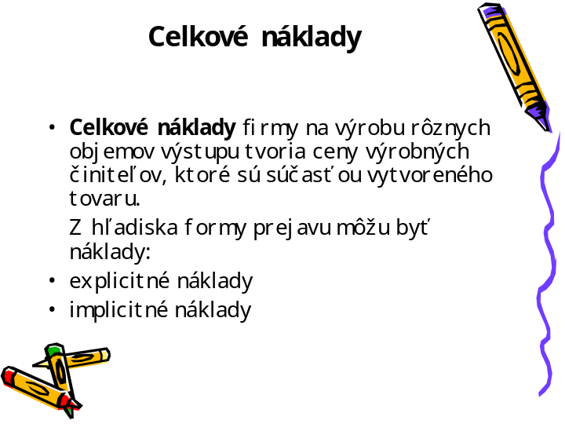

____________________________________________________________________________________________________________________________________________________________________________________________________________________________________________________________________________________________________________________________________________________________________________________________________________________________________________________________________________________________________________________________________________________________________________________________________________________________________________________________________________________________________________________________________________________________________________________________________________________________________________________________________________________________
snímek 5

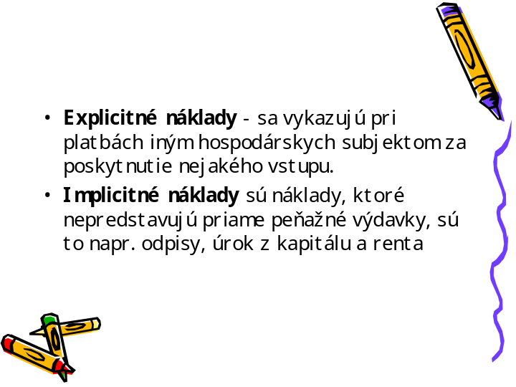

____________________________________________________________________________________________________________________________________________________________________________________________________________________________________________________________________________________________________________________________________________________________________________________________________________________________________________________________________________________________________________________________________________________________________________________________________________________________________________________________________________________________________________________________________________________________________________________________________________________________________________________________________________________________
snímek 6

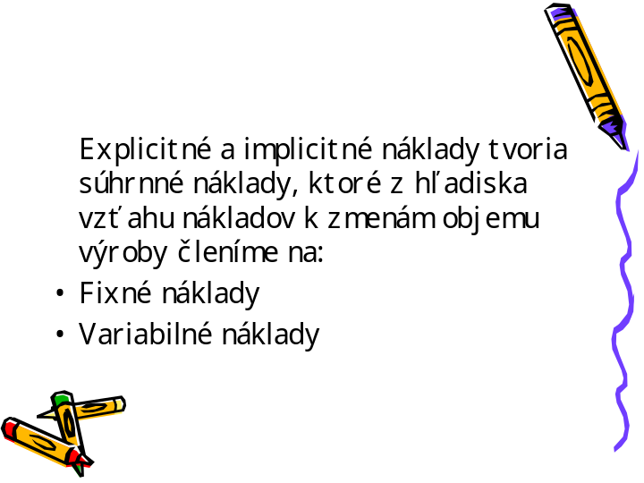

____________________________________________________________________________________________________________________________________________________________________________________________________________________________________________________________________________________________________________________________________________________________________________________________________________________________________________________________________________________________________________________________________________________________________________________________________________________________________________________________________________________________________________________________________________________________________________________________________________________________________________________________________________________________
snímek 7

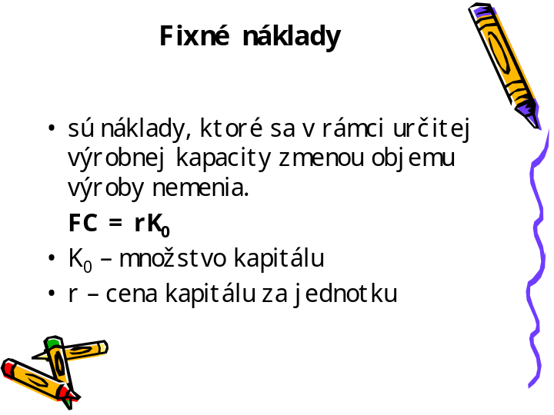

____________________________________________________________________________________________________________________________________________________________________________________________________________________________________________________________________________________________________________________________________________________________________________________________________________________________________________________________________________________________________________________________________________________________________________________________________________________________________________________________________________________________________________________________________________________________________________________________________________________________________________________________________________________________
snímek 8

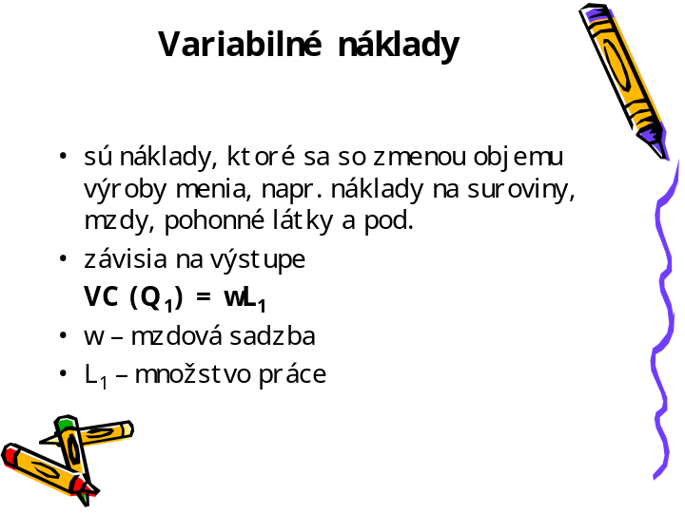

____________________________________________________________________________________________________________________________________________________________________________________________________________________________________________________________________________________________________________________________________________________________________________________________________________________________________________________________________________________________________________________________________________________________________________________________________________________________________________________________________________________________________________________________________________________________________________________________________________________________________________________________________________________________
snímek 9

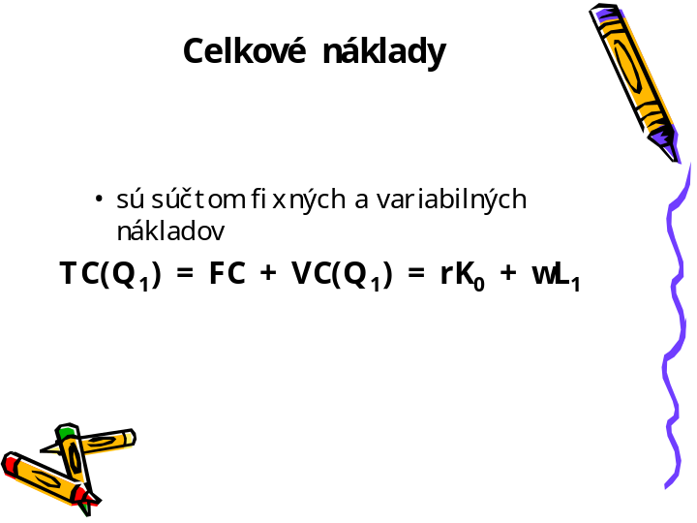

____________________________________________________________________________________________________________________________________________________________________________________________________________________________________________________________________________________________________________________________________________________________________________________________________________________________________________________________________________________________________________________________________________________________________________________________________________________________________________________________________________________________________________________________________________________________________________________________________________________________________________________________________________________________
snímek 10

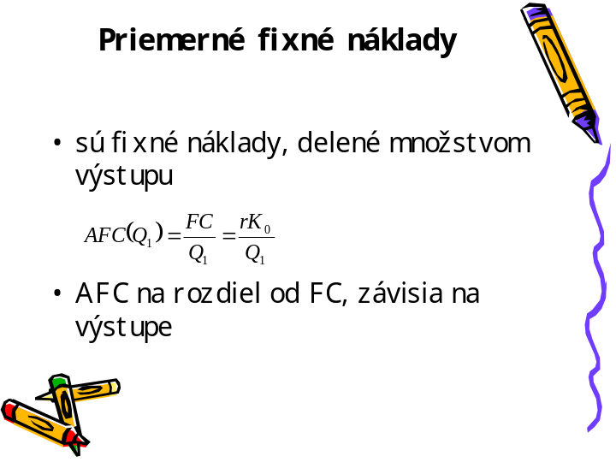

____________________________________________________________________________________________________________________________________________________________________________________________________________________________________________________________________________________________________________________________________________________________________________________________________________________________________________________________________________________________________________________________________________________________________________________________________________________________________________________________________________________________________________________________________________________________________________________________________________________________________________________________________________________________
snímek 11

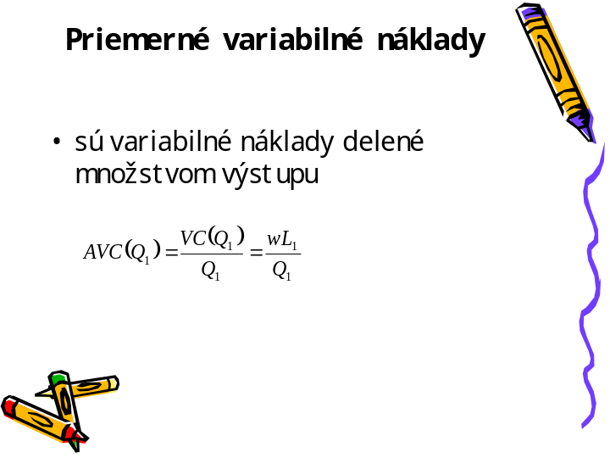

____________________________________________________________________________________________________________________________________________________________________________________________________________________________________________________________________________________________________________________________________________________________________________________________________________________________________________________________________________________________________________________________________________________________________________________________________________________________________________________________________________________________________________________________________________________________________________________________________________________________________________________________________________________________
snímek 12

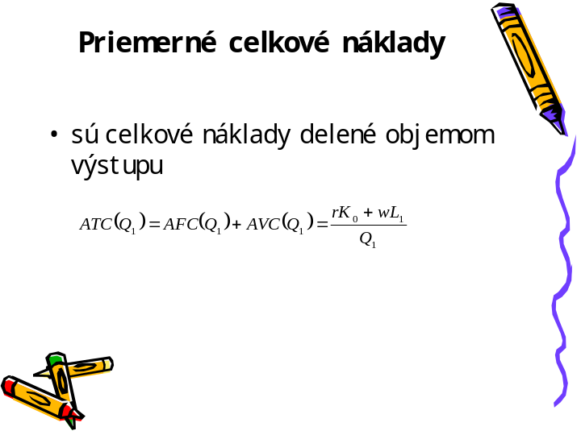

____________________________________________________________________________________________________________________________________________________________________________________________________________________________________________________________________________________________________________________________________________________________________________________________________________________________________________________________________________________________________________________________________________________________________________________________________________________________________________________________________________________________________________________________________________________________________________________________________________________________________________________________________________________________
snímek 13

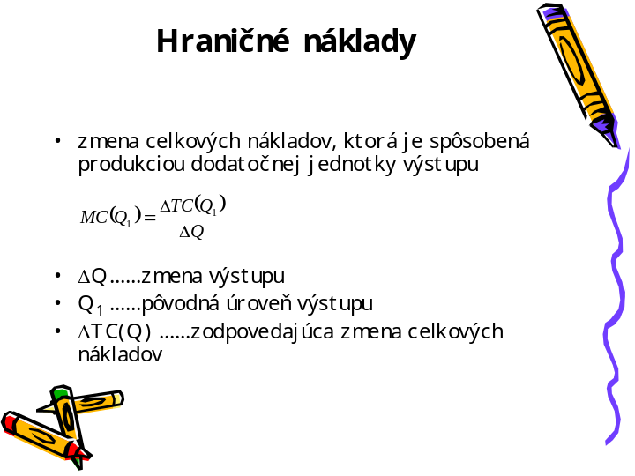

____________________________________________________________________________________________________________________________________________________________________________________________________________________________________________________________________________________________________________________________________________________________________________________________________________________________________________________________________________________________________________________________________________________________________________________________________________________________________________________________________________________________________________________________________________________________________________________________________________________________________________________________________________________________
snímek 14

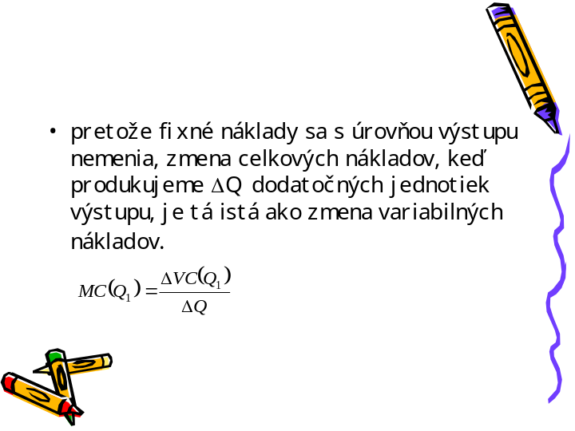

____________________________________________________________________________________________________________________________________________________________________________________________________________________________________________________________________________________________________________________________________________________________________________________________________________________________________________________________________________________________________________________________________________________________________________________________________________________________________________________________________________________________________________________________________________________________________________________________________________________________________________________________________________________________
snímek 15

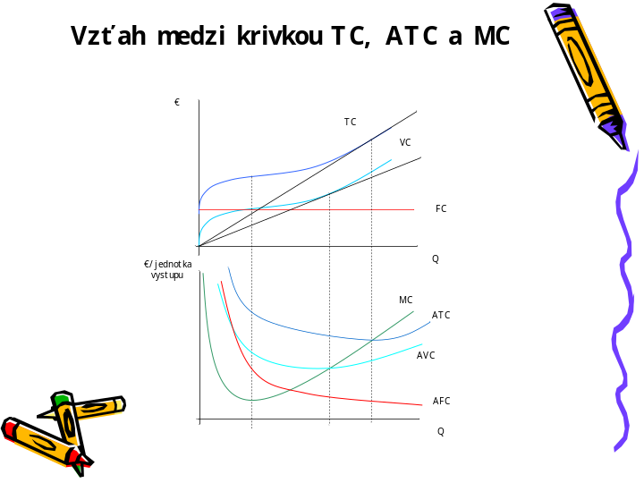

____________________________________________________________________________________________________________________________________________________________________________________________________________________________________________________________________________________________________________________________________________________________________________________________________________________________________________________________________________________________________________________________________________________________________________________________________________________________________________________________________________________________________________________________________________________________________________________________________________________________________________________________________________________________
snímek 16

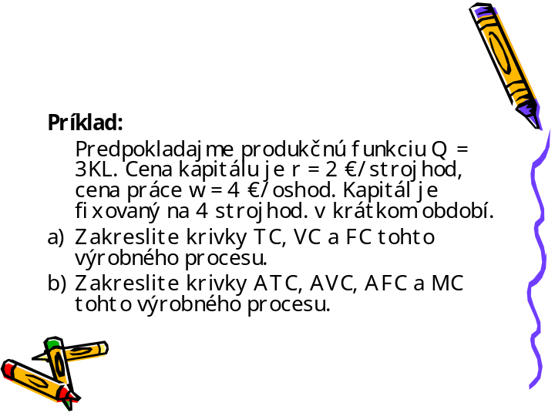

____________________________________________________________________________________________________________________________________________________________________________________________________________________________________________________________________________________________________________________________________________________________________________________________________________________________________________________________________________________________________________________________________________________________________________________________________________________________________________________________________________________________________________________________________________________________________________________________________________________________________________________________________________________________
snímek 17

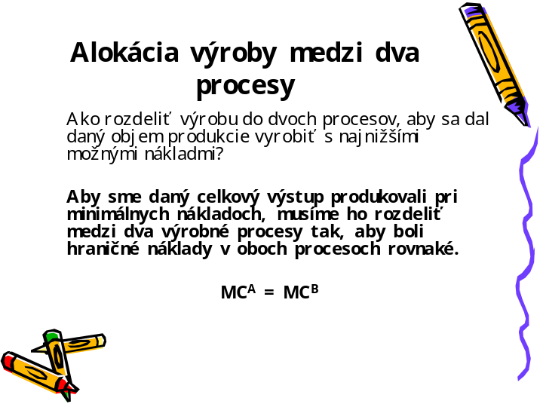

____________________________________________________________________________________________________________________________________________________________________________________________________________________________________________________________________________________________________________________________________________________________________________________________________________________________________________________________________________________________________________________________________________________________________________________________________________________________________________________________________________________________________________________________________________________________________________________________________________________________________________________________________________________________
snímek 18

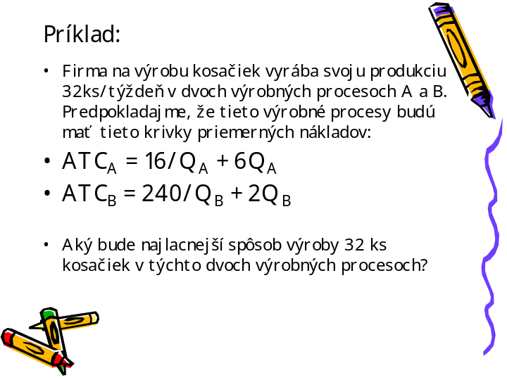

____________________________________________________________________________________________________________________________________________________________________________________________________________________________________________________________________________________________________________________________________________________________________________________________________________________________________________________________________________________________________________________________________________________________________________________________________________________________________________________________________________________________________________________________________________________________________________________________________________________________________________________________________________________________
snímek 19

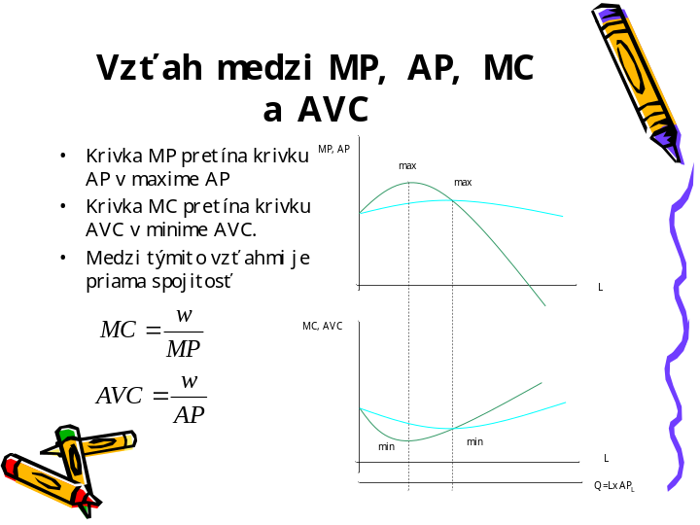

____________________________________________________________________________________________________________________________________________________________________________________________________________________________________________________________________________________________________________________________________________________________________________________________________________________________________________________________________________________________________________________________________________________________________________________________________________________________________________________________________________________________________________________________________________________________________________________________________________________________________________________________________________________________
snímek 20

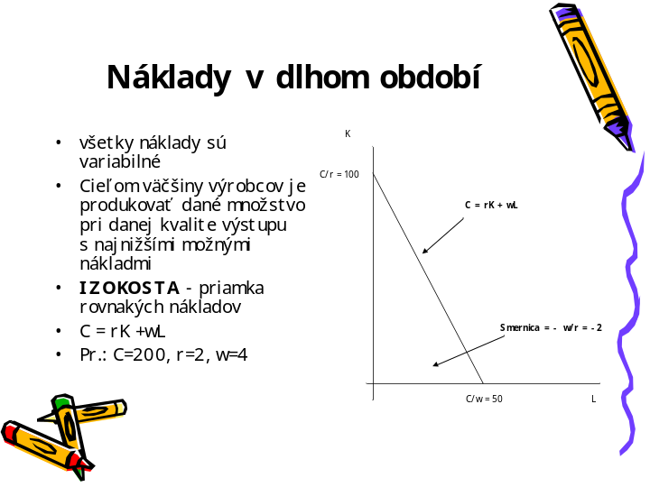

____________________________________________________________________________________________________________________________________________________________________________________________________________________________________________________________________________________________________________________________________________________________________________________________________________________________________________________________________________________________________________________________________________________________________________________________________________________________________________________________________________________________________________________________________________________________________________________________________________________________________________________________________________________________
snímek 21

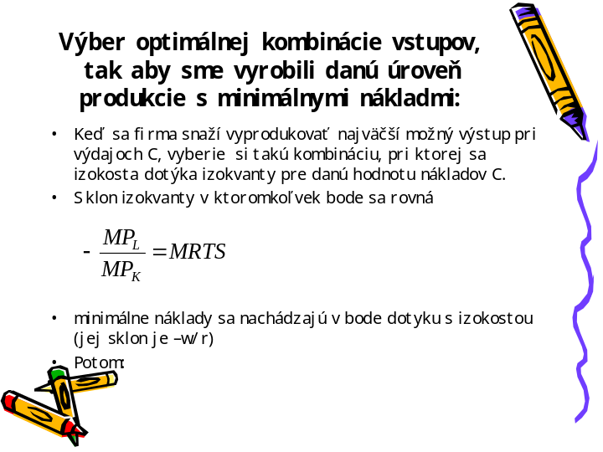

____________________________________________________________________________________________________________________________________________________________________________________________________________________________________________________________________________________________________________________________________________________________________________________________________________________________________________________________________________________________________________________________________________________________________________________________________________________________________________________________________________________________________________________________________________________________________________________________________________________________________________________________________________________________
snímek 22

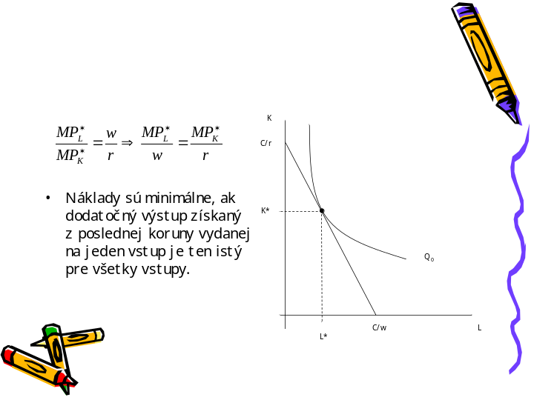

____________________________________________________________________________________________________________________________________________________________________________________________________________________________________________________________________________________________________________________________________________________________________________________________________________________________________________________________________________________________________________________________________________________________________________________________________________________________________________________________________________________________________________________________________________________________________________________________________________________________________________________________________________________________
snímek 23

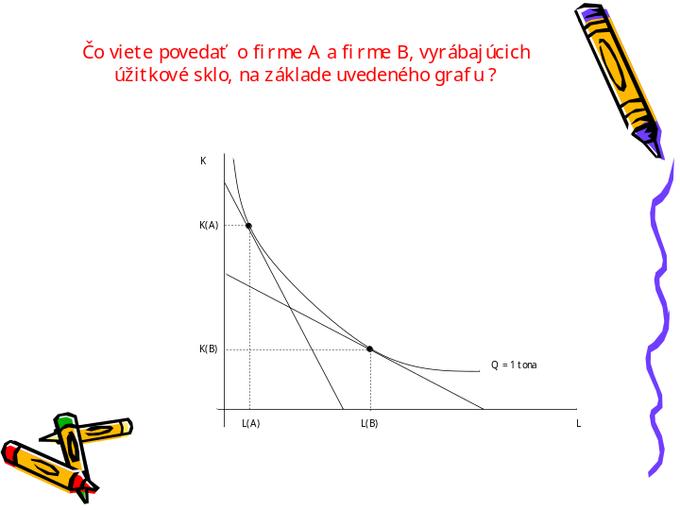

____________________________________________________________________________________________________________________________________________________________________________________________________________________________________________________________________________________________________________________________________________________________________________________________________________________________________________________________________________________________________________________________________________________________________________________________________________________________________________________________________________________________________________________________________________________________________________________________________________________________________________________________________________________________
snímek 24

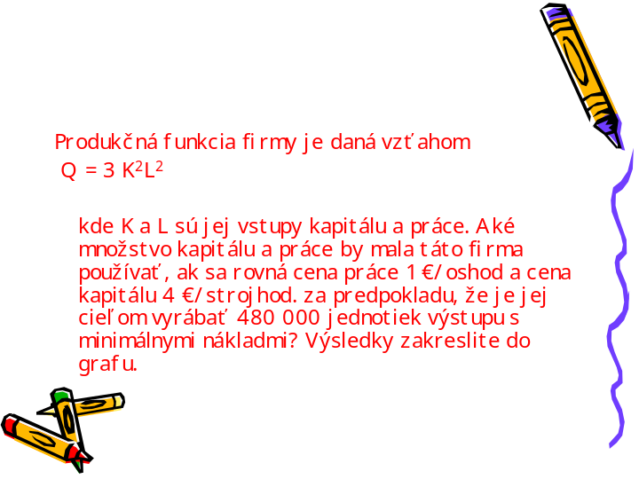

____________________________________________________________________________________________________________________________________________________________________________________________________________________________________________________________________________________________________________________________________________________________________________________________________________________________________________________________________________________________________________________________________________________________________________________________________________________________________________________________________________________________________________________________________________________________________________________________________________________________________________________________________________________________
snímek 25

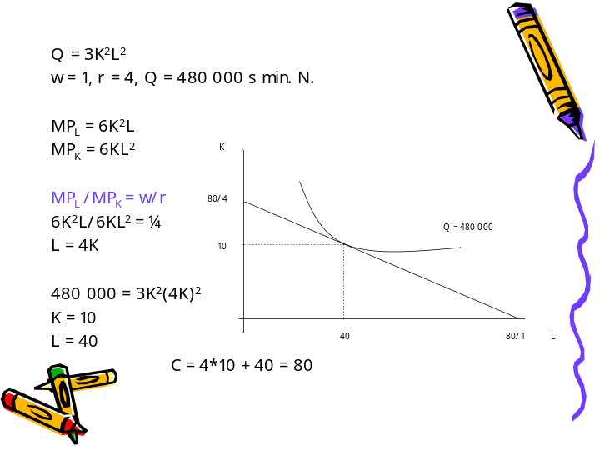

____________________________________________________________________________________________________________________________________________________________________________________________________________________________________________________________________________________________________________________________________________________________________________________________________________________________________________________________________________________________________________________________________________________________________________________________________________________________________________________________________________________________________________________________________________________________________________________________________________________________________________________________________________________________
snímek 26

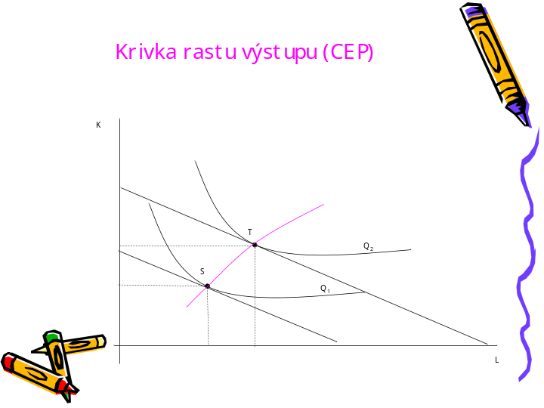

____________________________________________________________________________________________________________________________________________________________________________________________________________________________________________________________________________________________________________________________________________________________________________________________________________________________________________________________________________________________________________________________________________________________________________________________________________________________________________________________________________________________________________________________________________________________________________________________________________________________________________________________________________________________
snímek 27

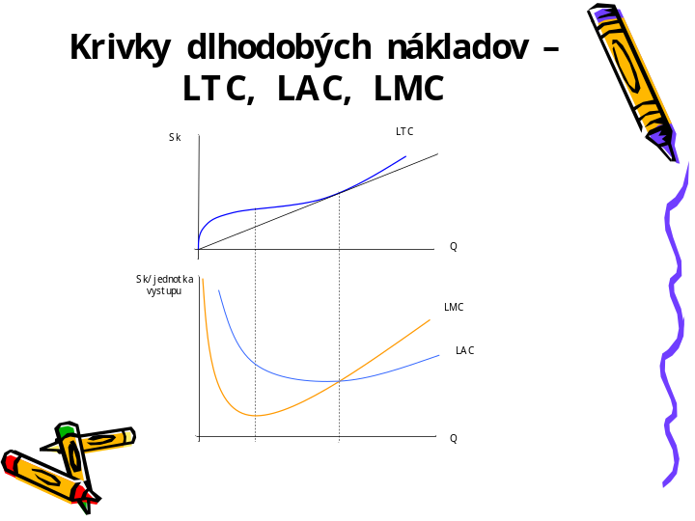

____________________________________________________________________________________________________________________________________________________________________________________________________________________________________________________________________________________________________________________________________________________________________________________________________________________________________________________________________________________________________________________________________________________________________________________________________________________________________________________________________________________________________________________________________________________________________________________________________________________________________________________________________________________________
snímek 28

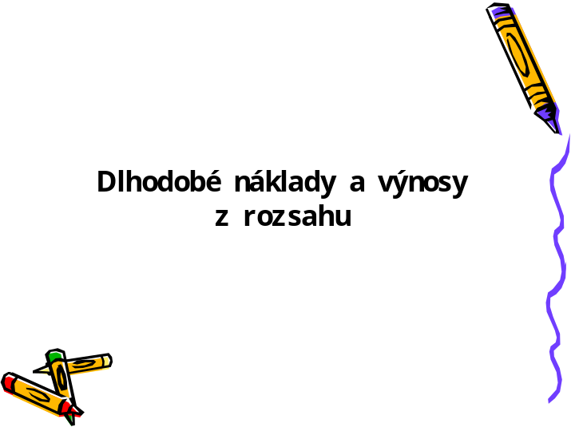

____________________________________________________________________________________________________________________________________________________________________________________________________________________________________________________________________________________________________________________________________________________________________________________________________________________________________________________________________________________________________________________________________________________________________________________________________________________________________________________________________________________________________________________________________________________________________________________________________________________________________________________________________________________________
snímek 29

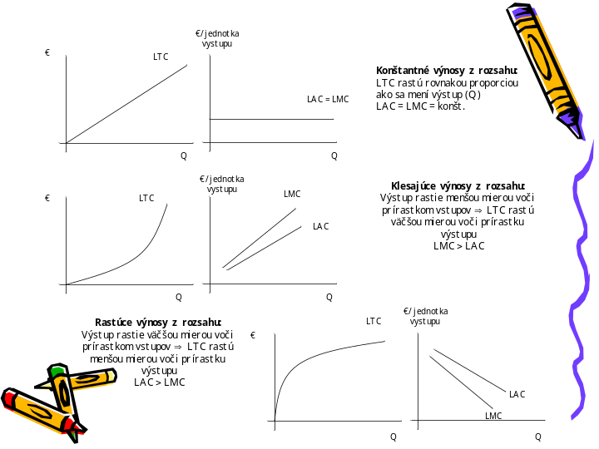

____________________________________________________________________________________________________________________________________________________________________________________________________________________________________________________________________________________________________________________________________________________________________________________________________________________________________________________________________________________________________________________________________________________________________________________________________________________________________________________________________________________________________________________________________________________________________________________________________________________________________________________________________________________________
snímek 30

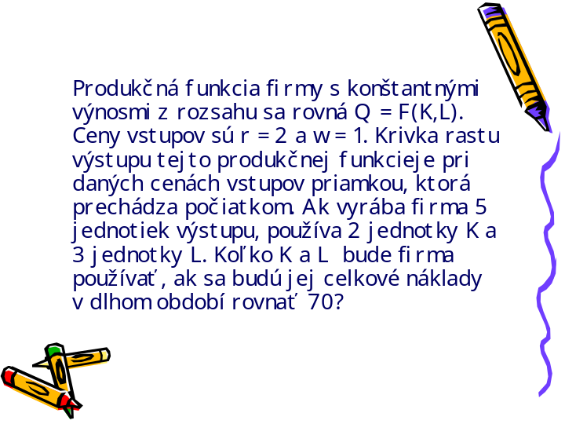

____________________________________________________________________________________________________________________________________________________________________________________________________________________________________________________________________________________________________________________________________________________________________________________________________________________________________________________________________________________________________________________________________________________________________________________________________________________________________________________________________________________________________________________________________________________________________________________________________________________________________________________________________________________________
snímek 31

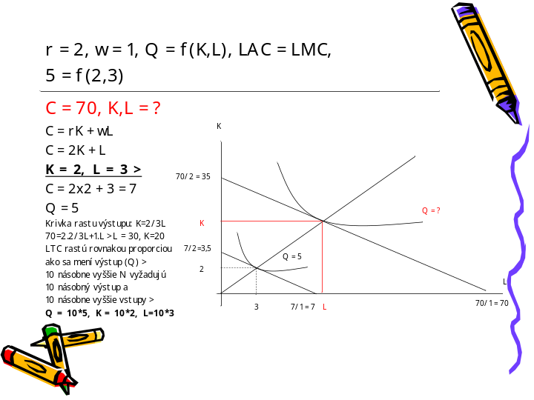

____________________________________________________________________________________________________________________________________________________________________________________________________________________________________________________________________________________________________________________________________________________________________________________________________________________________________________________________________________________________________________________________________________________________________________________________________________________________________________________________________________________________________________________________________________________________________________________________________________________________________________________________________________________________
snímek 32

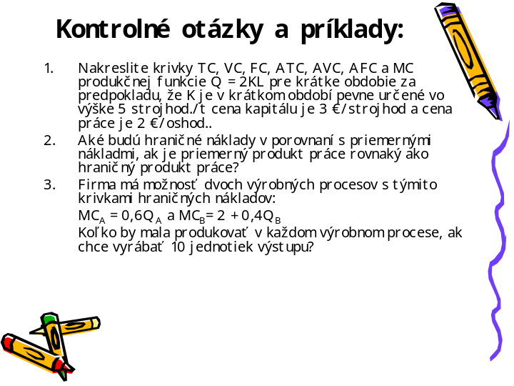

____________________________________________________________________________________________________________________________________________________________________________________________________________________________________________________________________________________________________________________________________________________________________________________________________________________________________________________________________________________________________________________________________________________________________________________________________________________________________________________________________________________________________________________________________________________________________________________________________________________________________________________________________________________________
snímek 33

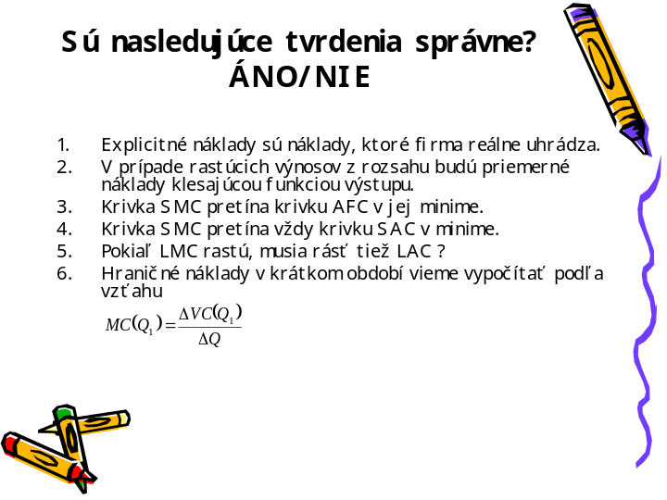

____________________________________________________________________________________________________________________________________________________________________________________________________________________________________________________________________________________________________________________________________________________________________________________________________________________________________________________________________________________________________________________________________________________________________________________________________________________________________________________________________________________________________________________________________________________________________________________________________________________________________________________________________________________________
snímek 34

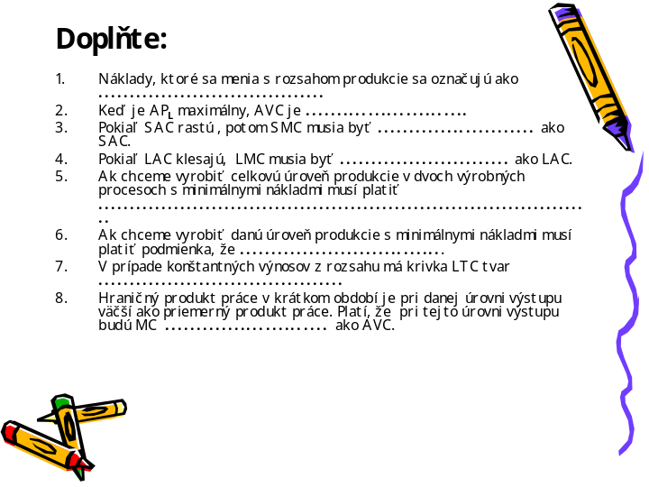

____________________________________________________________________________________________________________________________________________________________________________________________________________________________________________________________________________________________________________________________________________________________________________________________________________________________________________________________________________________________________________________________________________________________________________________________________________________________________________________________________________________________________________________________________________________________________________________________________________________________________________________________________________________________
snímek 35

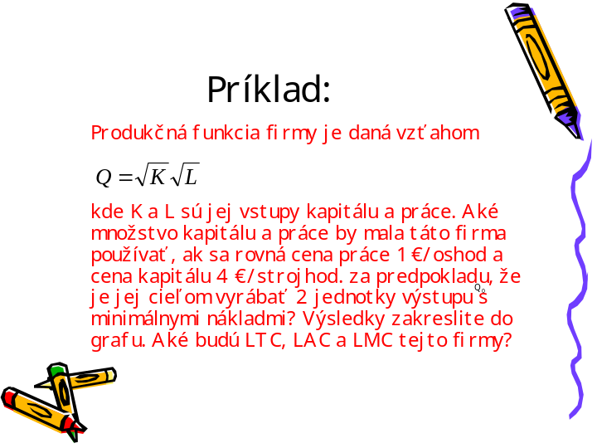

____________________________________________________________________________________________________________________________________________________________________________________________________________________________________________________________________________________________________________________________________________________________________________________________________________________________________________________________________________________________________________________________________________________________________________________________________________________________________________________________________________________________________________________________________________________________________________________________________________________________________________________________________________________________
snímek 36





